**Shortest Job First Scheduling**

*(Java Program)*

**COMSATS University Islamabad**

Sahiwal Campus



***Usama Sarwar***

FA17-BS(CS)-090-B

***Mr. Umer***

Operating System Concepts

October 29, 2019

Table of Contents

I. Non-Primitive Algorithm 1

A. Example: 1

1. Gantt Chart 1

2. Calculations 1

B. Java Method for Non-Preemptive 2

1. Output: 3

II. Primitive Algorithm 4

A. Example 4

1. Gantt Chart 4

2. Calculations 4

B. Java Method for Preemptive Algorithm 5

1. Output 6

List of Tables

Table 1. Values for Non-Preemptive SJF Algorithm 1

Table 2. Gantt Chart (Non-Preemptive) 1

Table 3. Results of Non-Preemptive SJF Algorithm 1

Table 4. Values for Preemptive SJF Algorithm 4

Table 5. Jantt Chart (Preemtive) 4

Table 6. Results of Preemptive SJF Algorithm 4

List of Figures

Figure 1. Console Output for Non-Preemptive Algorithm 3

Figure 2. Console Output for Preemptive Algorithm 6

Shortest Job First

# Non-Primitive Algorithm

Suppose we have set of processes are in ready queue. The SJF scheduling algorithm will choose the job which has shortest remaining time to complete. We have 2 variations of this SJF algorithm that are preemptive and non-preemptive. **Preemptive version of SJF also known as SRTF**. (Li, Kavi et al. 2007)

## ****Example**:**

|  |  |  |
| --- | --- | --- |
| **Process id** | **Arrival time** | **Burst time** |
| P1 | 0 | 3 |
| P2 | 0 | 1 |
| P3 | 0 | 2 |

Table 1. Values for Non-Preemptive SJF Algorithm

We have 3 processes in our ready queue. As we discussed SJF will schedule the job which is having least execution time or burst time.

### ****Gantt Chart****

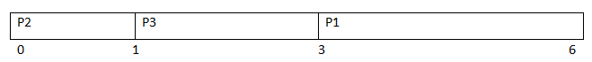

Table 2. Gantt Chart (Non-Preemptive)

Now we will calculate the completion time, waiting time, turnaround time of each process.

|  |  |  |  |
| --- | --- | --- | --- |
| **Process id** | **Completion time** | **Waiting time** | **Turnaround time** |
| P1 | 6 | 3 | 6 |
| P2 | 1 | 0 | 1 |
| P3 | 3 | 1 | 3 |

Table 3. Results of Non-Preemptive SJF Algorithm

### ****Calculations****

**Average waiting time** = (3+0+1)/3 = 1.33

**Turnaround time** = (6+1+3)/3 = 3.33

## Java Method for Non-Preemptive

public void NonPreemptive() {

System.out.print("Number of Processes: ");

int n = sc.nextInt();

int pid[] = new int[n];

int at[] = new int[n]; // at means arrival time

int bt[] = new int[n]; // bt means burst time

int ct[] = new int[n]; // ct means complete time

int ta[] = new int[n]; // ta means turn around time

int wt[] = new int[n]; //wt means waiting time

int f[] = new int[n]; // f means it is flag it checks process is completed or not

int st = 0, tot = 0;

float avgwt = 0, avgta = 0;

for (int i = 0; i < n; i++) {

System.out.print("Process " + (i + 1) + " Arrival Time:");

at[i] = sc.nextInt();

System.out.print("Process " + (i + 1) + " Brust Time:");

bt[i] = sc.nextInt();

pid[i] = i + 1;

f[i] = 0;

}

boolean a = true;

while (true) {

int c = n, min = 999;

if (tot == n) // total no of process = completed process loop will be terminated

{

break;

}

for (int i = 0; i < n; i++) {

if ((at[i] <= st) && (f[i] == 0) && (bt[i] < min)) {

min = bt[i];

c = i;

}

}

if (c == n) {

st++;

} else {

ct[c] = st + bt[c];

st += bt[c];

ta[c] = ct[c] - at[c];

wt[c] = ta[c] - bt[c];

f[c] = 1;

tot++;

} }

System.out.println("\nPid\tArrival\tBrust\tComplete\tTurn\tWaiting");

for (int i = 0; i < n; i++) {

avgwt += wt[i];

avgta += ta[i];

System.out.println(pid[i] + "\t" + at[i] + "\t" + bt[i] + "\t" + ct[i] + "\t\t" + ta[i] + "\t" + wt[i]);

}

System.out.println("\nAverage TAT is " + (float) (avgta / n));

System.out.println("Average Waiting Time is " + (float) (avgwt / n));

sc.close();

}

### Output:

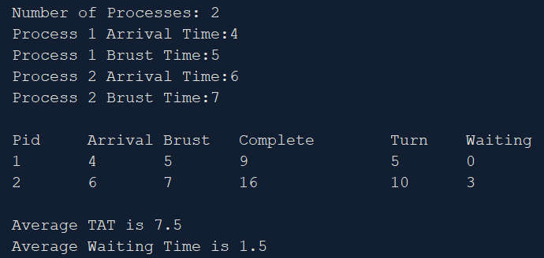

Figure 1. Console Output for Non-Preemptive Algorithm

# Primitive Algorithm

In SRTF the selection of job is same like in SJF. But the difference is In SJF process will run till completion. In SRTF process will run till completion or a new process added into queue which is having smaller execution time than the current process remaining execution time. (Bandarupalli, Nutulapati et al. 2012)

## Example

|  |  |  |
| --- | --- | --- |
| Process id | Arrival time | Burst time |
| P1 | 2 | 3 |
| P2 | 1 | 2 |
| P3 | 3 | 4 |
| P4 | 5 | 6 |

Table 4. Values for Preemptive SJF Algorithm

When process is added to queue or process is completed then only CPU may switch the process.

### Gantt Chart

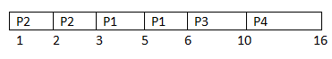

Table 5. Jantt Chart (Preemtive)

|  |  |  |  |
| --- | --- | --- | --- |
| Process id | Completion time | Waiting time | Turnaround time |
| P1 | 6 | 1 | 4 |
| P2 | 3 | 0 | 2 |
| P3 | 10 | 3 | 7 |
| P4 | 16 | 5 | 11 |

Table 6. Results of Preemptive SJF Algorithm

### Calculations

**Average turnaround time** = (4+2+7+11)/4 = 6.0

**Average waiting time** = (1+0+3+5)/4 = 2.25

## Java Method for Preemptive Algorithm

public void Preemptive() {

System.out.print("Number of Process: ");

int n = sc.nextInt();

int pid[] = new int[n]; // it takes pid of process

int at[] = new int[n]; // at means arrival time

int bt[] = new int[n]; // bt means burst time

int ct[] = new int[n]; // ct means complete time

int ta[] = new int[n];// ta means turn around time

int wt[] = new int[n]; // wt means waiting time

int f[] = new int[n]; // f means it is flag it checks process is completed or not

int k[] = new int[n]; // it is also stores brust time

int i, st = 0, tot = 0;

float avgwt = 0, avgta = 0;

for (i = 0; i < n; i++) {

pid[i] = i + 1;

System.out.print("Process " + (i + 1) + " Arrival Time:");

at[i] = sc.nextInt();

System.out.print("Process " + (i + 1) + " Burst Time:");

bt[i] = sc.nextInt();

k[i] = bt[i];

f[i] = 0; }

while (true) {

int min = 99, c = n;

if (tot == n) {

break; }

for (i = 0; i < n; i++) {

if ((at[i] <= st) && (f[i] == 0) && (bt[i] < min)) {

min = bt[i];

c = i; } }

if (c == n) {

st++;

} else {

bt[c]--;

st++;

if (bt[c] == 0) {

ct[c] = st;

f[c] = 1;

tot++;

} } }

for (i = 0; i < n; i++) {

ta[i] = ct[i] - at[i];

wt[i] = ta[i] - k[i];

avgwt += wt[i];

avgta += ta[i]; }

System.out.println("PID\tArrival\tBurst\tComplete\tTurn\tWaiting");

for (i = 0; i < n; i++) {

System.out.println(pid[i] + "\t" + at[i] + "\t" + k[i] + "\t" + ct[i] + "\t\t" + ta[i] + "\t" + wt[i]); }

System.out.println("\nAverage TAT is " + (float) (avgta / n));

System.out.println("Average Waiting Time is " + (float) (avgwt / n));

sc.close();

}

### Output

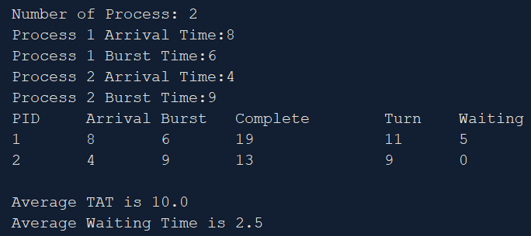

Figure 2. Console Output for Preemptive Algorithm

References

Bandarupalli, S. B., et al. (2012). "A Novel CPU Scheduling Algorithm–Preemptive & Non-Preemptive." International Journal of Modern Engineering Research (IJMER) **2**(6): 4484-4490.

Li, W., et al. (2007). "A non-preemptive scheduling algorithm for soft real-time systems." Computers & Electrical Engineering **33**(1): 12-29.